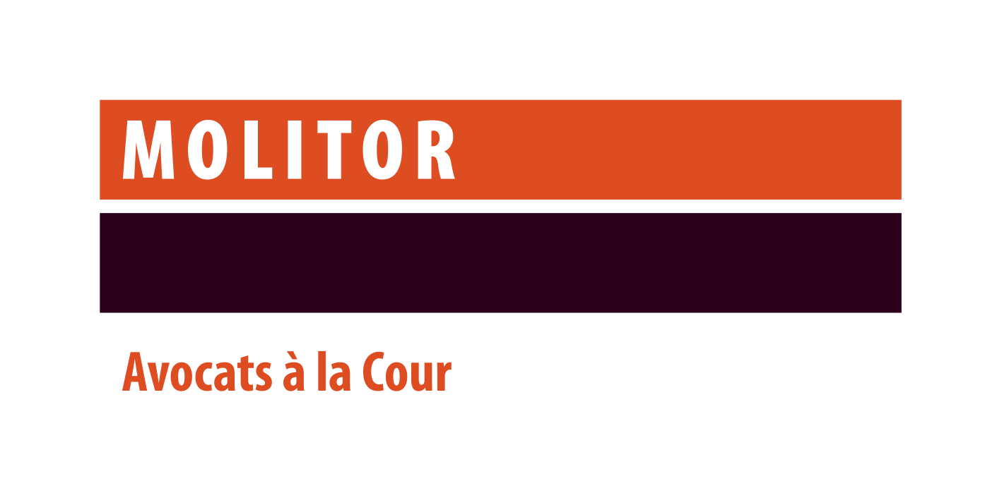

**Lawyer for our Litigation & Dispute Resolution practice**

**Contact: Sophie Icher**

**Head of HR and Organisation**

**sophie.icher@molitorlegal.lu**

**Your mission**

Assisting our clients in a variety of litigation matters relating to Banking & Finance, Investment Management and in Restructuring & Insolvency matters.

**Your profile**

* University degree in law completed by a post-graduate degree;
* Member of the Luxembourg Bar;
* At least 5 years’ experience in a recognized law firm and a solid technical background in litigation.
* Personal communications skills;
* Excellent written communication and drafting skills;
* Fluent (written and spoken) in both French and English. Proficiency in Luxembourgish and German would be highly appreciated;
* Team player and client oriented

**What we offer**

You will be part of an international team of lawyers, operating in an exciting business environment of a full-service law firm dealing with both domestic and international client networks. To foster your continuous professional development, we offer you both internal and external training. You will be challenged from day one and will be working both autonomously as well as in project teams.

We have a strong focus on how we recruit train and reward our staff and always ensure that they are fully aligned with our work culture built around our four fundamental values: Service Excellence, Integrity & Trust, Teamwork and Approachability.

 Our staff work together cohesively, applying our key values of placing team goals above individual goals and focusing on building trust and rapport with our clients, who note that approachability is one of our differentiating traits, alongside service excellence.